Installation Requirements.
Visualise™ Braille and tactile signs are designed for installation using a self-adhesive backing. This installation method eliminates the presence of screw or bolt heads on the face of the sign. An optional screw-on backing plate is available for installation onto rough or irregular surfaces – simply screw the backing plate to the wall, then adhere the sign to the backing plate.
While Visualise™ Braille and tactile signs conform to the relevant Standards and Codes, they must be installed in the correct location for full compliance. The Building Code of Australia (D3.6) states:
- Signs must be installed between 1200mm and 1600mm above the floor or ground surface.
- Signs with single lines of characters must have the line of tactile characters between 1250mm and 1350mm above the floor or ground surface.
Figure 1: Leading edge to be between 50mm and 300mm from architrave.
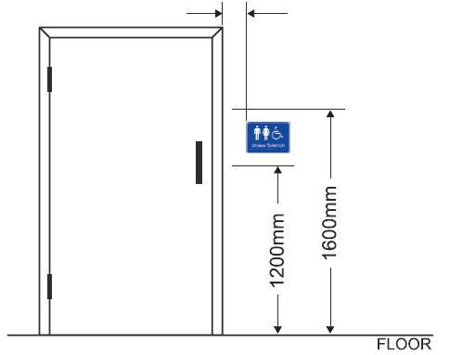
Figure 2: Signs with single lines of characters must have the line of tactile characters between 1250mm and 1350mm above the floor or ground surface.
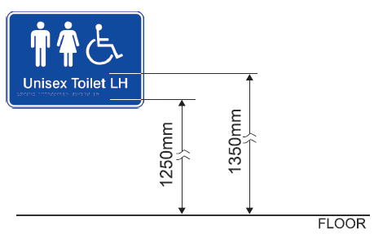
Signs identifying rooms containing facilities or features listed in the Building Code of Australia D3.6 must be installed:
- on the wall on the door handle side of the door with the leading edge of the sign located between 50mm and 300mm from the architrave,
- if installation (1) is not possible, the sign may be placed on the door.
Exit Level # signs identifying a door required by the BCA E4.5must be installed:
- on the side that faces a person seeking egress, and
- on the wall on the door handle side of the door with the leading edge of the sign located between 50mmand 300mm from the architrave,
- if installation (2) is not possible, the sign may be placed on the door.

